## **How to Create Google Forms: A Beginner’s Guide**

Can anyone create Google forms? The answer is yes! To create a survey in Google Forms, no coding knowhow is required – a Google account is all you need.

With that, let’s get started. Here’s your guide on how to create a Google Form in 2024.



All you need is a Gmail account to access Google Drive. Click on the New Button in Drive to access Google Forms

First, log in to your [Google Drive](https://drive.google.com/) or the Google Forms app. Let’s begin!

### **Create your form**

* Click on the **New +** button in Drive or **Blank form +** in the Forms tool.
* If you’re logging in from Drive, select **Google Forms**.
* Choose an option: **Blank form**, **Blank quiz**, or **Template**. For our purpose, we will choose a Blank form.
* An Untitled form opens up. You can add a title and description.



In Google Forms, there’s a dropdown next to each question that allows you to change the format.

### **Add survey questions**

* Click on **Add Question ⊕**
* Select a format: multiple-choice, file uploads, dropdown, and more.
* Edit your question and answer wording.
* Click, drag and drop to rearrange the question order.



With Google Forms File Upload question type, you can allow specific file types and set the maximum file size.

### **Update survey questions**

* To move a question, click **Drag** at the top.
* Use the **File upload** question to let people upload specific file types to your Drive. Respondents can upload a maximum of 10 files up to 10 GB.
* To copy a question, click on the **Duplicate** icon. Use this option if you want to use the same format for the next question.
* To remove questions, click **Delete** 🗑.
* For making the question mandatory, adjust the **Required** toggle as shown in the GIF.

And your survey is ready for all the bells and whistles!

### **Customize your Google Form layout**

On the right side of the question, you will see a floating toolbar with the following options:

* **Add question.**
* **Import questions** to copy questions from an existing Form.
* **Add title and description** to introduce the next section with a new set of questions.
* **Add image** to add a supporting image. You can upload a picture, click one with your webcam, insert from a URL or plug in an image straight from Google Drive or search.
* **Add video.** But you are only allowed to add one from YouTube.
* **Add section** to break up a lengthy form.



Click on the paintbrush icon to open customization options for your Google Form survey

### **Customize your Google Form design**

To add a little spice to your survey, go to the **Customize** icon at the top right. Click it to explore the four available options:

1. **Header:** Upload an appropriate header image for your survey.
2. **Theme Color:** Choose from the available color options or add a custom color.
3. **Background Color:** Insert a suitable background color according to your preference.
4. **Font Style:** Change the font to match your Form’s style.

## **Google Forms: Additional Settings**

### **Configure your form**

Go to the **Settings** tab to configure your Google Form.

#### **Share as a quiz💡**

* Turn on the **Make this a quiz** toggle.
* Under **Release Grades,** you can opt to release the scores immediately, or later after manual review.
* Under **Respondent Settings**, you can enable respondents to see correct and incorrect answers, and the points they got on each question.
* With **Global Quiz Defaults**, you can assign a default point value for each new question.

#### **Control access 🔑**

* Manage how responses are collected and protected under **Responses**.
* Under **Collect email addresses,** you can opt to collect emails verified by the respondents or collect them manually.
* You can enable response editing after submission. Also, you can opt to send a copy of the response on request.
* To restrict a Form to users within your organization, turn on the **Restrict** toggle.

#### **Control form presentation👁️‍🗨️**

* Opt to show a progress bar, shuffle the questions, or disable autosave of the responses.
* You can also edit the survey submission message or show a link to submit another response.

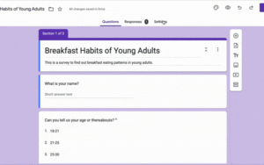

### **Review your Google Form**

At the top right, next to Customize, click **Preview**.

* This creates a working link to the form in a new tab.
* After filling out form, click **Submit** to record your response**.**
* **Note**: Submitting the sample form may affect your final results. This is because all of your Google survey responses (even sample ones) are included in the total.

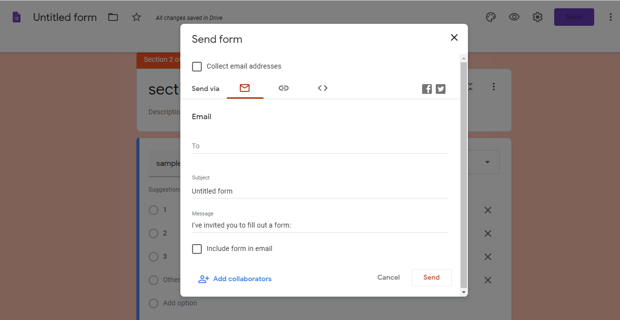

### **Share your form**

Click on **Send** to view three options.

* **Email:** Add the email IDs you want to send the form to, along with the subject and a message.
* **Link***:* This generates a link to the survey, which can be shortened to comply with character limits. Click on **Copy** to copy the link.
* **Embed HTML:** This option generates a code snippet to add your Form to a webpage or blog. Visitors to the page can access and fill this form. However, Google Forms won’t let you use Embed HTML if your survey has a File Upload question.
* Additionally, you can also share your Form on Facebook and Twitter.



In Google Forms settings, you can choose to share the survey as General, Presentation or Quizzes.

### **View form responses**

Under the **Responses** tab, we have:

* **Accepting responses**: Adjust this toggle to stop accepting further responses.
* **Summary:** Get an overview of the form’s performance.
* **Question:** Do a question-wise analysis on the number of responses.
* **Individuals:** View the complete set of responses from each participant.
* **Link to Sheets:** Export the answers to a new Google Sheet or an existing one.

**References:**

1. [**How to Make a Google Form (C omplete Beginner Tutorial)**](https://youtu.be/tLjbn_KAec0?si=pAf2YWPCxn7oUU03)